Understanding decimals with tenths >1
Section A: Partition each of these as shown, e.g 2.4kg = 2kg + 0.4kg
3.8 m = ______m + ______ m

4.5 kg =

2.6 =

3.3 =
Partition each of these in many different ways,
e.g. 2.4kg = 2kg + 0.4kg = 1kg + 1.4kg = 2.1kg + 0.3kg

Section B: Complete the following:
3.4m = ____ x 0.1m = $\frac{ }{10}$ m 16 x 0.1l = _______ l

4.9m = 28 x 0.1kg =

0.5 = 31 x 0.1 =

Sam has written some different ways to describe the picture. Tick or cross to show if he is right or wrong. Where he is wrong, write a correct expression:
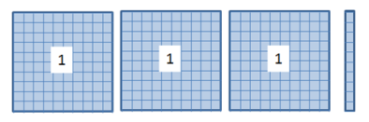
(30 x 0.1) + (1 x 0.1) 0.3 + 1
3 – 0.1 $\frac{31}{10}$
$\frac{40}{10}$ - $\frac{9}{10}$ 1 + 0.1 + 2

Order from smallest to largest, using < sign to join expressions, e.g. 2 < 4 < 9 < 11
0.4, $\frac{34}{10}$, 2.8, 0.1 x 24, 3, 13 + 0.1, 13 x 0.1

______________________________________________________________

