7.55 Graham mentions a question where students are required to find the equation of a line (though he misremembers the line) [Edexel Paper 2, Q22(F), Q3(H)]
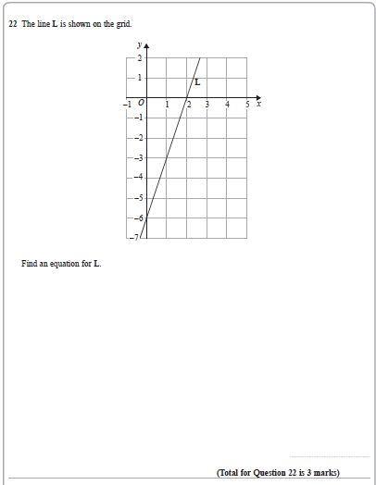
19:18 Andrew refers to the first question on one of AQA’s papers [AQA Paper 1(F), Q1]
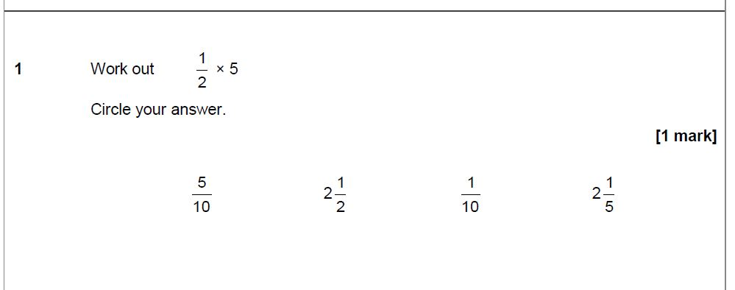
21:28 Neil mentions a question involving rotational symmetry of an octagon [OCR, Paper 3(F), Q1b]
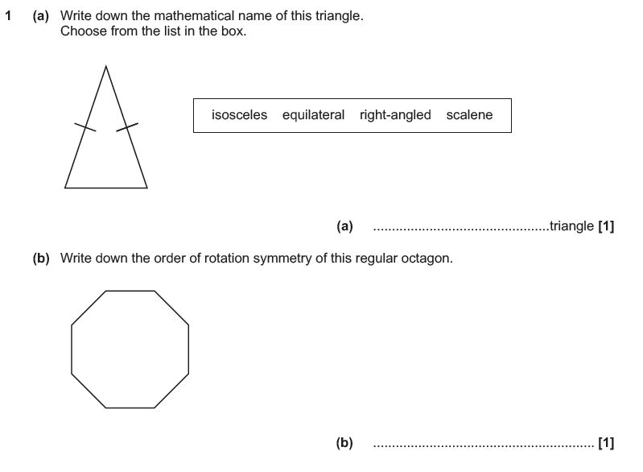
23:55 Andrew mentions a question about the properties of a rhombus [AQA Paper 3(H), Q13]
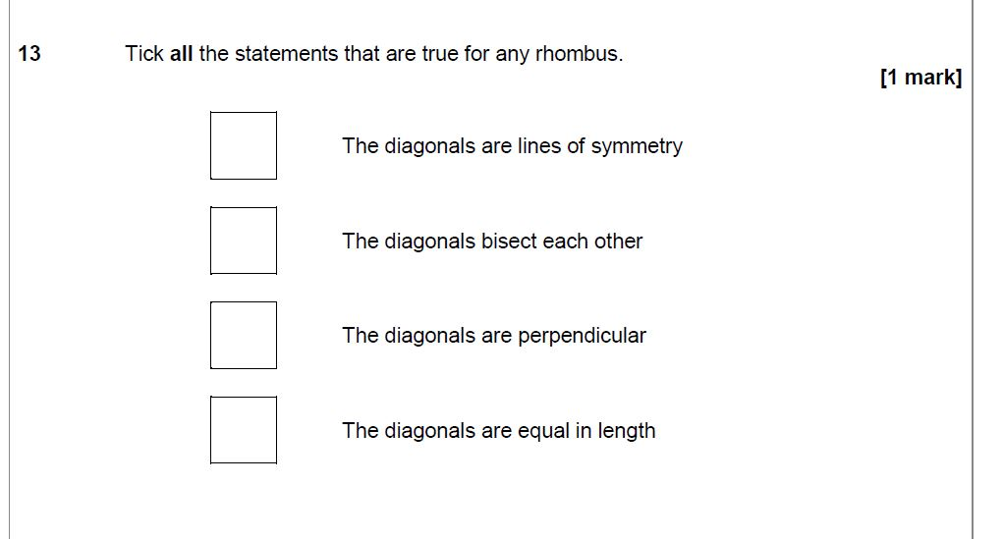
24:30 Graham refers to a vector question on the Higher paper [Edexel Paper 1, Q26(H)]
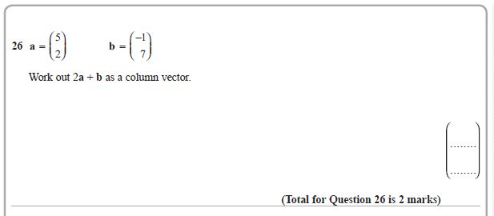
25:47 Graham mentions a question about a bicycle race: [Edexel Paper 1 Q22(F), Q4(H)]
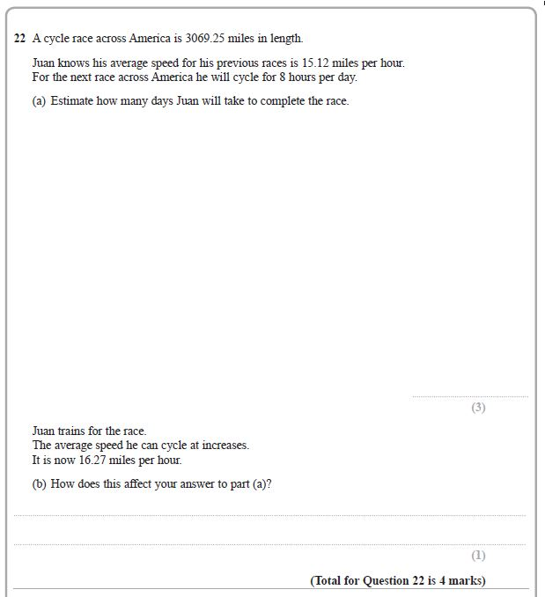
32:06 Graham refers to a question about a tennis court [Edexel Paper 3, Q12(F)]
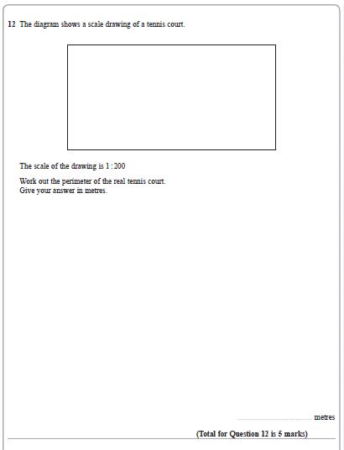
32:37 Graham talks about a question involving house prices [Edexel Paper 3, Q11(H)]
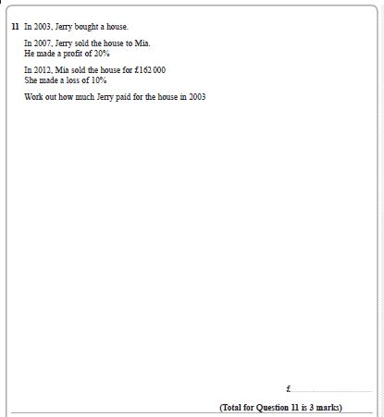
33:50 Neil talks about a proof question [OCR Paper 5(H), Q15]
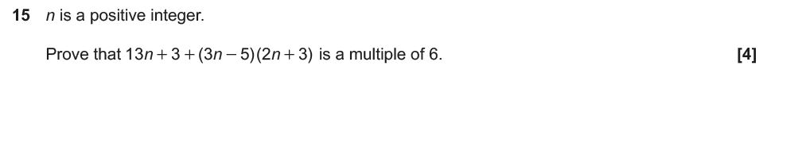
35:07 Neil talks about a poorly understood vectors question [OCR Paper3(F), Q12c(ii)]
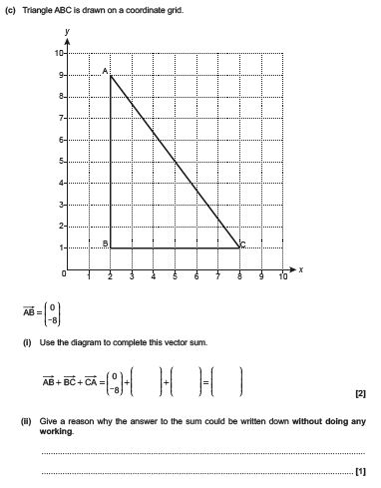
36:20 Graham refers to a perimeter question with a triangle with sides in the ratio 3:4:5 [Edexel Paper 1, Q8(H)]
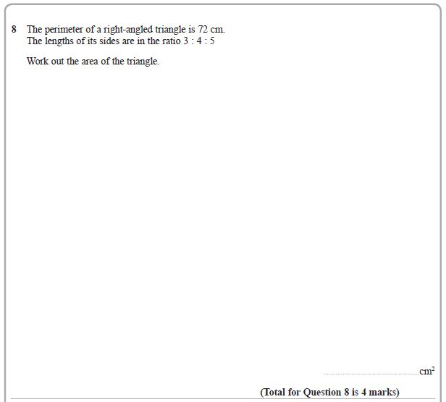
37:05 Graham refers to a question about 4 squares and finding co-ordinates [Edexel Paper 1, Q24(F), Q6(H)]
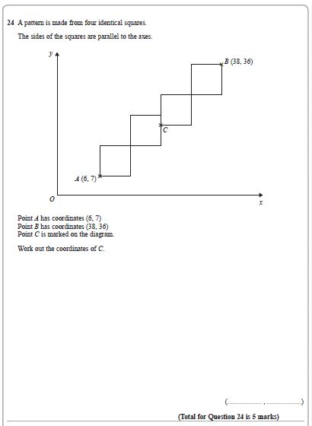
38:30 Andrew talks about an Area Under a Graph question [AQA Paper 3(H) Q24]
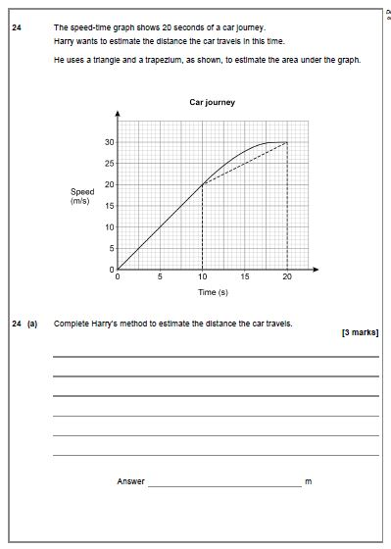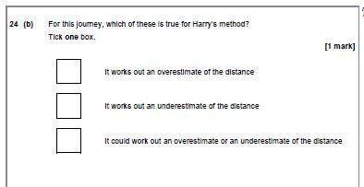
38:50 Andrew talks about a question involving a Venn diagram [AQA Paper 2 (H), Q25]
