**Shaping the Year 7 Curriculum:**

**Building on Year 6**

**Key Idea 3: Understanding the relationship between the numerator and the denominator in a fraction**

(6F–1 Simplify fractions; 6F–2 Express fractions in a common denomination; 6F–3 Compare fractions with different denominators).

A lot of early work on fractions in primary school is concerned with the part-whole model of fractions i.e. that if the whole is divided into, for example, 6 parts then 5 of those parts represent $\frac{5}{6}$ of the whole. In Year 6, pupils need to be able to understand the idea that the numerator and denominator are connected by a relationship, that the relationship helps when ordering fractions, and that the relationship remains the same for all equivalent fractions.

Pupils will have learnt about equivalent fractions in Year 5 and should be able to identify, name and write equivalent fractions. In Year 6 they should use this understanding to perform the inverse operation of simplifying fractions. They should know that the simplest form of any fraction is obtained by dividing both numerator and denominator by their highest common factor and be able to recognise when a fraction is in its simplest form.

Importantly, pupils should have a deep understanding of this process and, by the end of Year 6, be able to reason, for example that $\frac{6}{15}$ and $\frac{2}{5}$ have the same value because:

2 out of 5 equal parts is the same as 6 out of 15 equal parts

1. 2 as a part of 5 is the same as 6 as a part of 15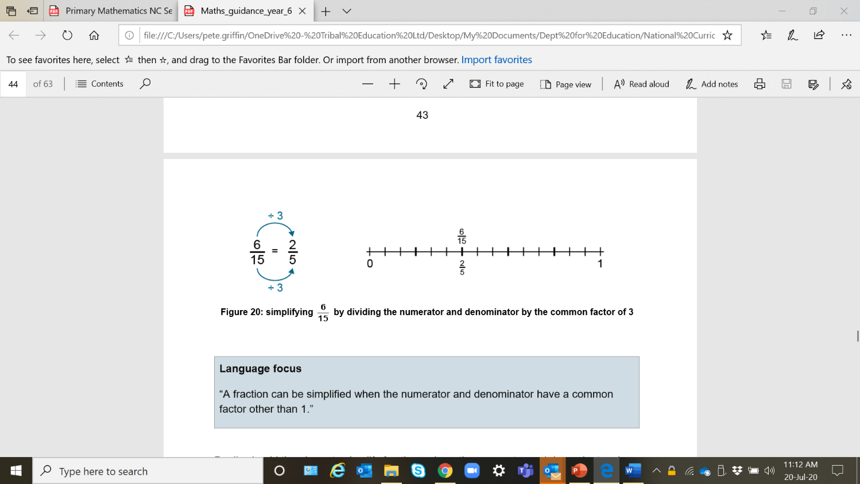

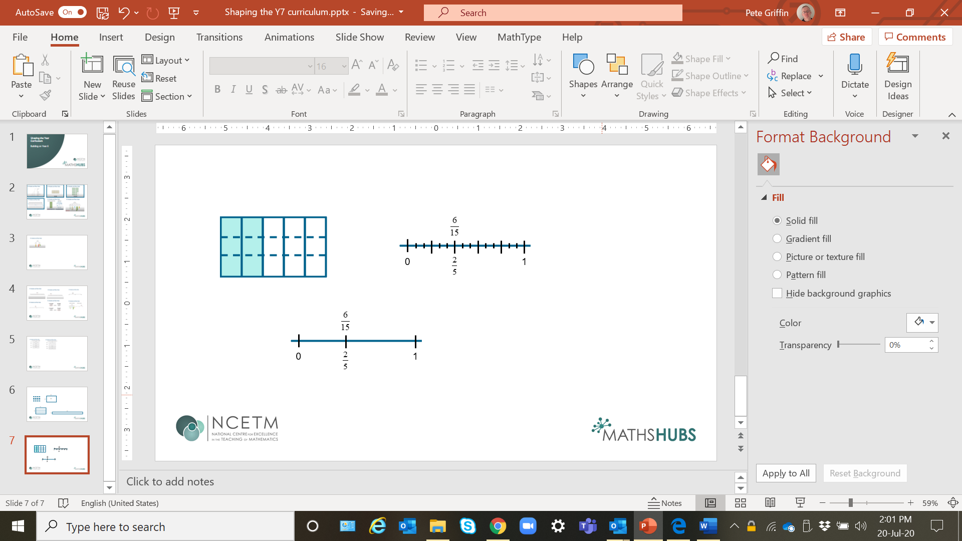

Similarly, pupils should be able to place, for example, $\frac{7}{11}$ and $\frac{5}{6}$ on a number line and know that, because 7 is a smaller part of 11, than 5 is of 6, then $\frac{7}{11}$ < $\frac{5}{6}$.

Also, they should be able to reason that, for example, $\frac{3}{4}$ > $\frac{3}{5}$ because when the numerators are the same, the larger the denominator, the smaller the fraction.

**Progression to Key Stage 3**

An important idea which develops in Key Stage 3 and builds on this secure understanding of fractions, including appreciating the connection between the numerator and the denominator, is the idea of fractions as ratios.

When calculating equivalent fractions or performing the inverse operation of simplifying fractions, attention is often on the (scalar) multiplier ***between*** the fractions, i.e.

×5

$\frac{2}{3}$ = $\frac{10}{15}$

÷5

To appreciate fractions as ratios, pupils are required to focus on the (functional) relationship ***within***a fraction:





$\frac{2}{3}$ = $\frac{10}{15}$

This paves the way for the consideration of ratio tables which are a useful structure for representing a range of ratio problems at Key Stage 3.

|  |  |
| --- | --- |
| 2 | 10 |
| 3 | 15 |

For further guidance on how to develop these important ideas in Key Stage 3, follow the links below to the relevant documents in the [NCETM Secondary PD Materials](https://www.ncetm.org.uk/teaching-for-mastery/mastery-materials/secondary-mastery-professional-development/).

**Theme Overviews:**

* [Theme 2: Operating on number](https://www.ncetm.org.uk/media/x2uj2qln/ncetm_ks3_theme_2.pdf)

Theme 2 is about students understanding the structures underpinning calculation using each of the four operations. It includes the solving of equations, which is essentially concerned with operations on as yet unknown numbers.

* [Theme 3: Multiplicative Reasoning](https://www.ncetm.org.uk/media/0mzbcnny/ncetm_ks3_theme_3.pdf)

Theme 3 addresses the idea that any two numbers can be connected by multiplication. This gives rise to ideas of ratio, proportionality, percentage increase and decrease, rates of change, enlargement, similarity, and trigonometric ratios.

**Core Concept documents:**

* [Core Concept 2.1: Arithmetic procedures](https://www.ncetm.org.uk/media/xhqegzuq/ncetm_ks3_cc_2_1.pdf)

This core concept offers guidance on developing a strong understanding of the mathematical structures that underpin the standard procedures for calculation with decimals, fractions and directed numbers.

* [Core Concept 3.1: Understanding multiplicative relationships](https://www.ncetm.org.uk/media/mqfp3xb3/ncetm_ks3_cc_3_1.pdf)

This core concept explores fractions, percentages, ratio, and proportion (direct and inverse) as contexts in which multiplicative relationships are used.

August 2020